CL-1002 Programming Fundamentals | LAB - 01  Problem solving with sequential structure using Scratch
NATIONAL UNIVERSITY OF COMPUTER AND EMERGING SCIENCES
Fall 2022
NATIONAL UNIVERSITY OF COMPUTER AND EMERGING SCIENCES
NATIONAL UNIVERSITY OF COMPUTER AND EMERGING SCIENCES
NATIONAL UNIVERSITY OF COMPUTER AND EMERGING SCIENCES

Introduction
Visual Programming Language (VPL) is an application development environment designed on a graphical block-based programming model.

Scratch Interface
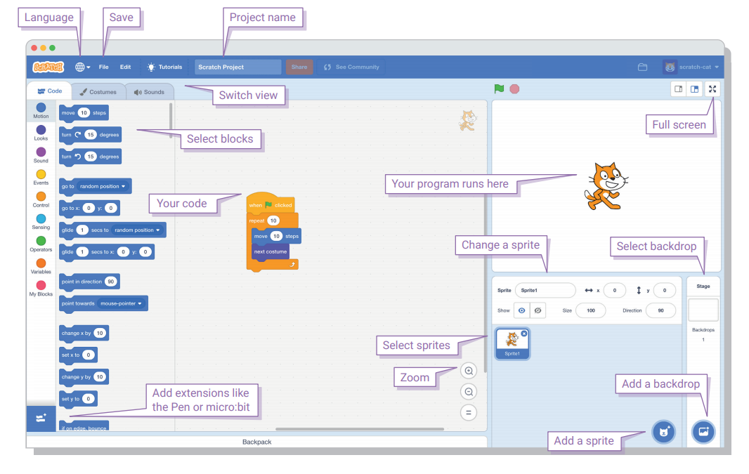

Example#1: Writing our first script in a scratch to print “Hello” to the world.

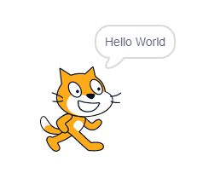
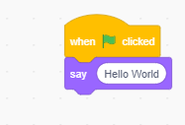
#include <stdio.h>
int main()
{
printf(“Hello World”);
}

Example#2: Prompting your Name and printing “Hello” to your Name.

Script: Output:

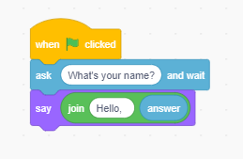
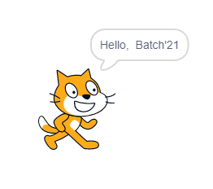
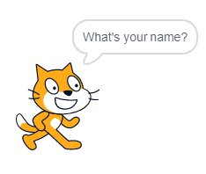

Example#3: Asking your Name and saying by speaking “Hello” to your Name.

Script:
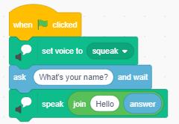

Example#4: Setting Grid Backdrop and moving spirit onto the xy-axis and draw square on the screen.

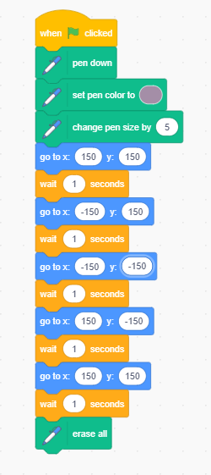
Script: Output:
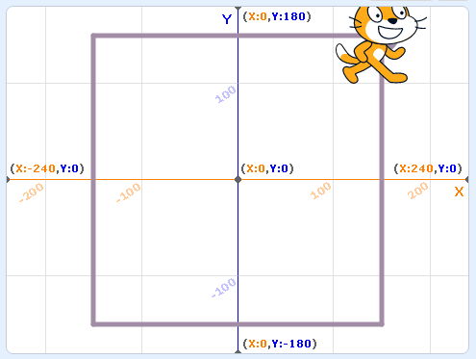

Example#5: Write a script of input two numbers, add two numbers and print the sum of numbers.

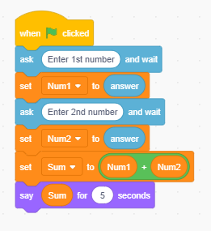
Script: Output:
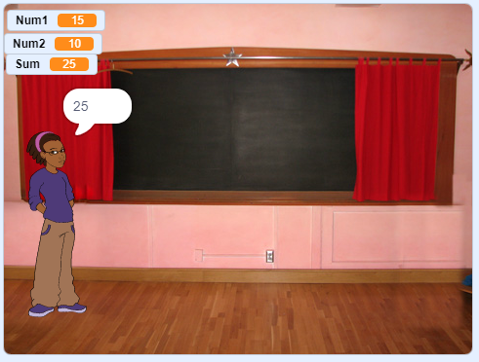

Example#6: Write a script to find an area of circle

Script: Output:
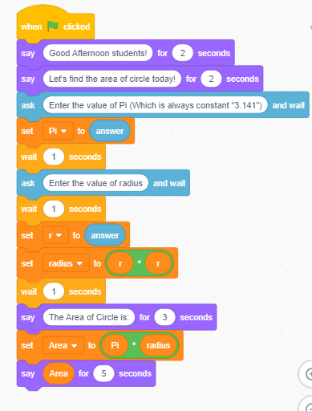
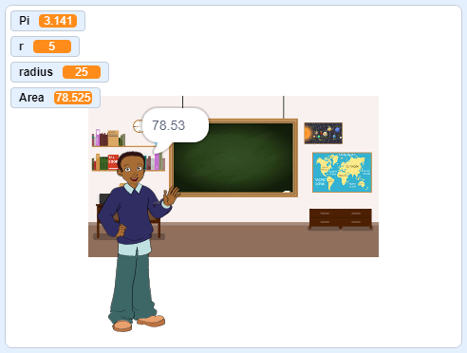

Example#7: Conversation between two scripts when clicked on the spirit.

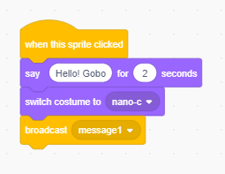
Spirit#1

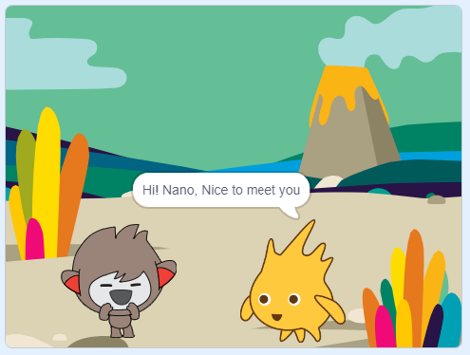

Spirit#2
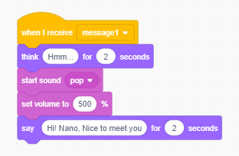

Lab Tasks
Task No. 1: Write a program in scratch to check if a given number is odd or even and display a suitable message.

Task No. 2: Make a simple calculator which takes two input values and an operation to be performed from the user and performs arithmetic operations such as addition, subtraction, division, and multiplication using scratch.

Task No. 3: Write a program to calculate the factorial of a number.

Task No. 4: Write a program to separate odd and even numbers in a given list.

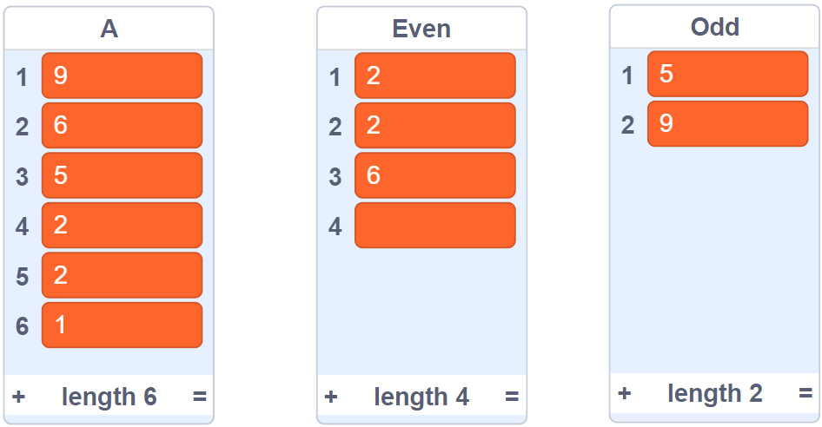

Task No 5: Calculate the area of a triangle in which the user inputs height and length of a triangle.

Task No 6: Using scratch evaluates an expression.

Sum = 1²+ 2²+ 3² + . . . . + N²

Task No 7: Calculate the square root of a given number using scratch. The number should be asked from the user.

Task No 8: Calculate the hypotenuse of right angle triangle with given two sides by pythagoras theorem using scratch.

